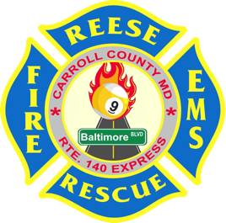
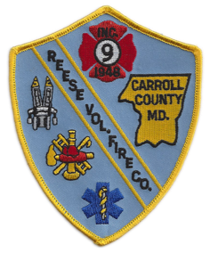
REESE AND COMMUNITY VOLUNTEER FIRE COMPANY

1st ANNUAL $50K BIG MONEY GIVE-A-WAY
$20,000 GRAND PRIZE
Saturday, August 24, 2024 (rain or shine) 12pm - 5pm
$90.00/Ticket until 5/31/24
LOCATION: 1745 Baltimore BLVD. Westminster, MD 21157
Permit #71
With this Ticket Request Form, you have the opportunity to purchase a ticket for $90.00. Entries must be post marked NO LATER THAN May 31, 2024 after that the ticket price will go back to $100.00. Each guest ticket is $25.00; they may be purchased at the door.
Food and the first drawing will start at 1pm. Ticket holders and guests receive ‘all you can eat’: Pit Beef, Pit Ham, Pit Turkey, Fried Chicken, French Fries, Salads, etc. and beverages (beer, soda, and water).
- All numbers will be drawn from our chance drum. We give ALL THE MONEY AWAY!!!
- You must be 18 years of age or older to purchase a Big Money ticket or guest ticket.
- Must be 21 years old or older for alcohol consumption. Proper ID required.
- Winners will have thirty (30) days to claim their prize or they will forfeit all rights to that prize.
- Winning numbers will be posted on our website, www.reesevfc.org
- All winners will be notified via telephone or mail.
- Winners need not be present to win.
- Winners will be responsible for any and all taxes.
- Reese and Community Volunteer Fire Company persons, business, or organizations participating in this drawing assumes NO liability for any claims of injury or other damages occurred from prizes on this ticket or from the day of the event.

MINIMUM SALES OF 600 TICKETS by August 1, 2024 or EVENT IS CANCELLED & TICKET PRICE IS REFUNDED.

TIME | AMOUNT | TIME | AMOUNT | TIME | AMOUNT | TIME | AMOUNT | TIME | AMOUNT
1:00 | $1,000 | 2:00 | $2,000 | 3:00 | $3,000 | 4:00 | $4,000 | 5:00 | $20,000
1:05 | $450 | 2:05 | $450 | 3:05 | $450 | 4:05 | $450
1:10 | $450 | 2:10 | $450 | 3:10 | $450 | 4:10 | $450
1:15 | $450 | 2:15 | $450 | 3:15 | $450 | 4:15 | $450
1:20 | $450 | 2:20 | $450 | 3:20 | $450 | 4:20 | $450
1:25 | $450 | 2:25 | $450 | 3:25 | $450 | 4:25 | $450
1:30 | $500 | 2:30 | $500 | 3:30 | $500 | 4:30 | $500
1:35 | $450 | 2:35 | $450 | 3:35 | $450 | 4:35 | $450
1:40 | $450 | 2:40 | $450 | 3:40 | $450 | 4:40 | $450
1:45 | $450 | 2:45 | $450 | 3:45 | $450 | 4:45 | $450
1:50 | $450 | 2:50 | $450 | 3:50 | $450 | 4:50 | $450
1:55 | $450 | 2:55 | $450 | 3:55 | $450 | 4:55 | $450
There will be other wheels of chance, raffles and 50/50 drawings available.

Any questions, contact either RVFC member:
Linda Bowen (443) 375-0328 or info@reesevfc.org

Detach here and return with the full ticket price to the address below 1st Annual $50k Big Money Give-A-Way

Reese and Community Volunteer Fire Company 1745 Baltimore BLVD Westminster, MD 21157 – ATTN: Big Money Give-A-Way Make check payable to Reese Fire Company.

Number of tickets: @ $90.00/each until 5/31/2024 = $

Name: Cell:

Address:

